1.

2.

3.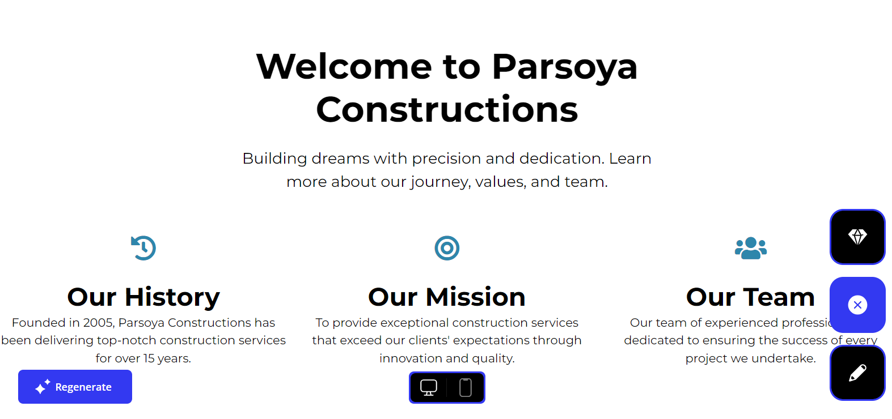

4.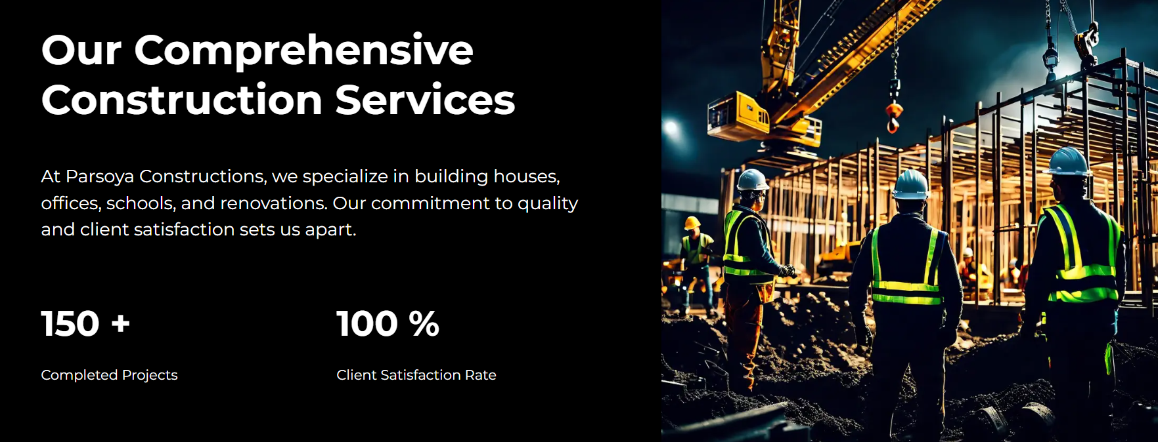

5.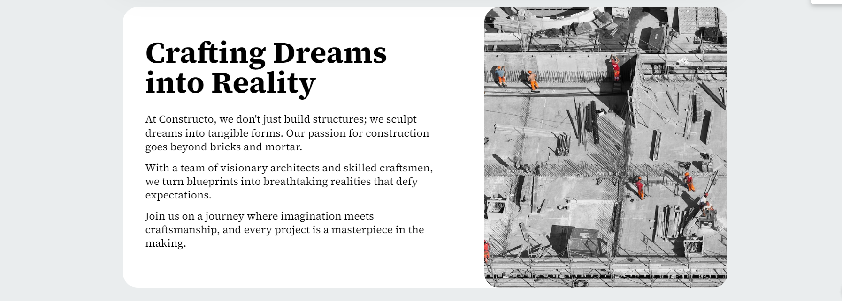

6.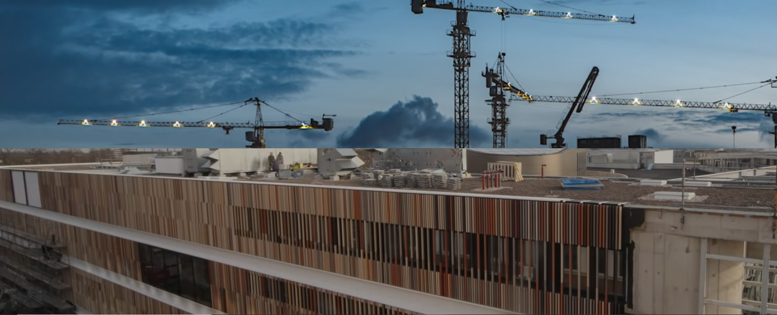

7.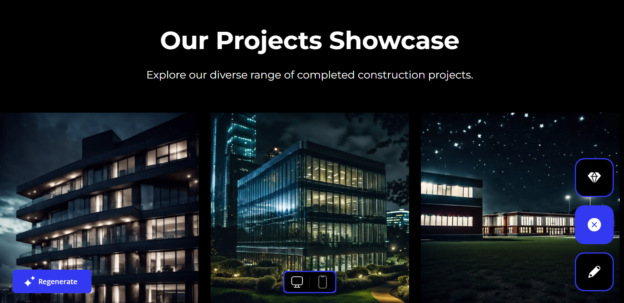

8.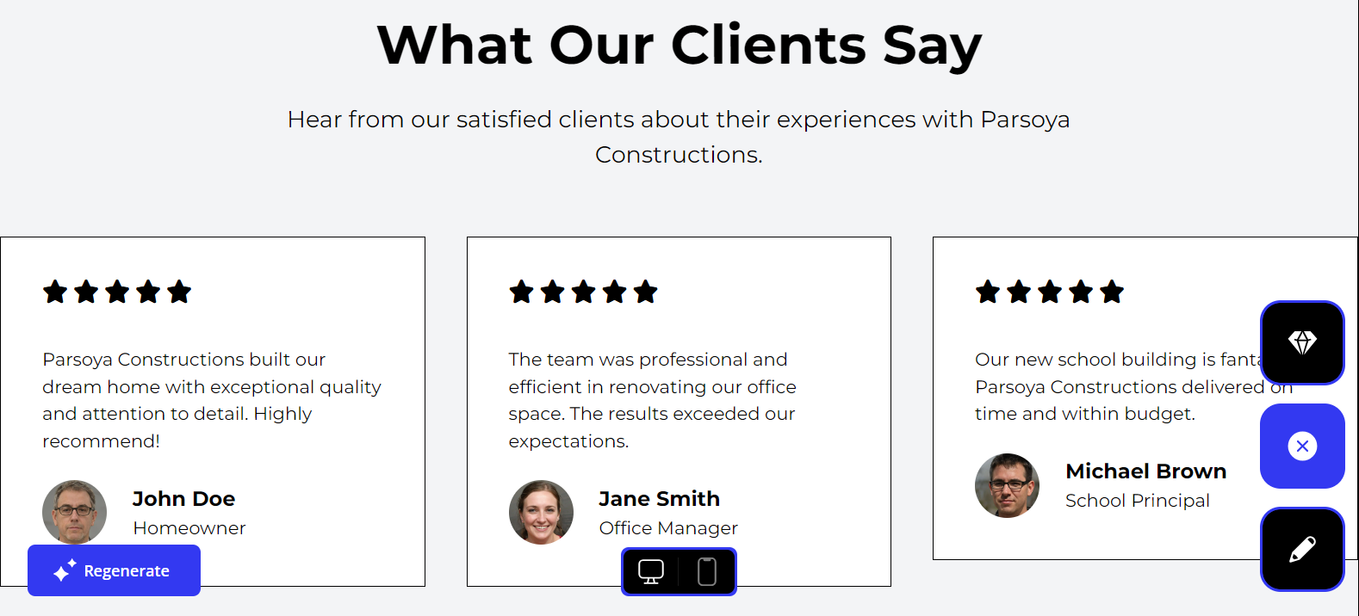

9.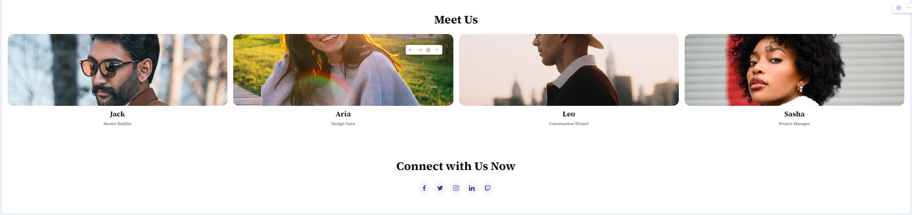

10.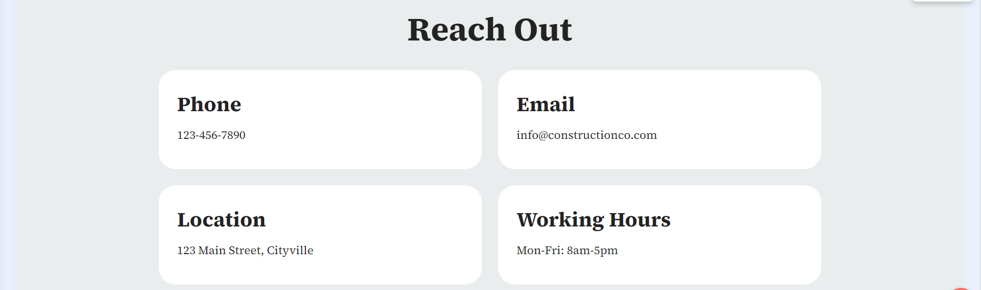

11.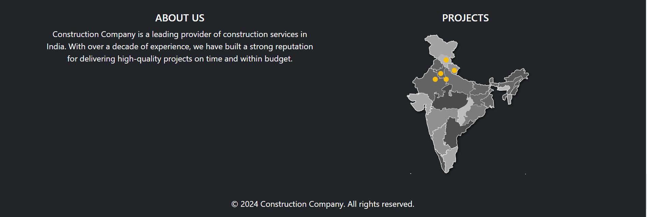

These links will work only in adjecti laptop// sign-in with [ravi.k@adjecti.com](mailto:ravi.k@adjecti.com) then the below sites will work.

<https://10web-site.ai/27/tender-catfish/>

<https://a.mobirise.com/>

1. The first screen will remain same but the height will be the same as in 2nd screen also the text will be the same as in 2nd screen. For primary navigation we will have only Home, About us, Landmark Projects. 2 buttons will be there on the home screen Our Services and Contact us similar as in 2nd screen. As soon as we scroll to next screen the navigation should also get scroll up and stick to the top section (same thing is working in both the above urls).
2. The 3rd screen will be the same.
3. The 4th screen will also be the same but with a slight change which is present in below other screen section (Refer 1st screen).
4. Again the 5th screen will be same.
5. The 6th screen is having a running video and this div will scroll as we scroll in both way upward or downward and the video is present in the same folder.
6. The 7th screen will be the same but with the white background.
7. Rest of the screens from 8th to 11th will be as it is. But reach out section will be white. In the same folder we have a gif which need to be placed on top of the Footer section.
8. The reference images is also present in the same folder.

Other screens

1.